[Company Logo]
Vulnerability and Patch Management Program
Finding weaknesses deliberately, fixing them within a stated period, and proving it happened

[Organization Name] Classification: Internal Use

Field | Detail
Document ID | PRG-VPM-001
Document title | Vulnerability and Patch Management Program
Version | 1.0
Status | [Draft / Approved]
Effective date | [Effective Date]
Document owner | [Owner Name, Role]
Approved by | [Approver Name, Role]
Approval date | [Date]
Next review | [Date, no more than 12 months from effective date]
Classification | Internal Use
Distribution | [Who this is issued to]

This document and all information contained in it is the property of [Organization Name]. Replace every bracketed field before issue, delete any clause that does not apply to your organization, and have it approved by a person with authority to do so. An unapproved, undated policy is not a control.

Table of Contents
Executive summary 4
1. What this program covers 4
1.1 Scope 4
1.2 What counts as a vulnerability 5
2. Who decides 5
2.1 Business process owner 6
2.2 Information technology 6
2.3 Security 6
3. Layered dependency 6
4. The window of exposure 7
4.1 The unknown window 7
4.2 The vendor window 7
4.3 The owner window 7
5. Program requirements 8
5.1 Asset inventory 8
5.2 Categorization by zone 8
5.3 Remediation periods 8
5.4 Identification 9
5.5 Remediation 9
6. Enforcement 9
7. Exceptions 10
8. Vendor-maintained and supplier systems 10
9. Compensating controls 10
10. Measurement and reporting 11
11. Review 11
12. Vulnerability identification in detail 12
12.1 Sources of vulnerability information 12
12.2 Scanning operations 12
13. Patch management in detail 13
13.1 The patch lifecycle 13
13.2 Testing 14
13.3 Deployment 14
13.4 Systems that cannot be patched 14
14. Penetration testing 15
14.1 Purpose 15
14.2 Scoping 15
14.3 Types 15
14.4 Handling findings 15
15. Exception process in detail 16
15.1 When an exception is appropriate 16
15.2 What an exception request records 16
15.3 Review and expiry 16
16. Reporting in detail 16
16.1 Operational reporting 16
16.2 Management reporting 16
16.3 Reporting to customers and assessors 17
Appendix D. Exception request form 18
Appendix E. Scan schedule 18
Appendix F. Remediation record 18
Appendix A. Roles and responsibilities 20
Appendix B. The proof chain 20
Appendix C. Evidence of operation 20
Glossary 21
Acronyms 21
Definitions 21
Record of changes 22

Executive summary
Unpatched and misconfigured systems remain the most common route by which organizations of this size are compromised. This program describes how the organization finds those weaknesses, decides what to do about each, fixes them within a stated period, and proves that the fix happened.
WHAT THIS PROGRAM IS AND WHY IT EXISTS
Vulnerability management is the practice of finding weaknesses deliberately, on a schedule, rather than discovering them during an incident. The alternative to vulnerability management is crisis management, and crisis management is considerably more expensive.
Being systematic reduces surprises. It also produces something an insurer, a customer or an auditor will accept, which improvised patching never does.
WHAT THIS DOCUMENT CONTAINS
Part One explains the concepts, including who holds authority over patching decisions and why the window of exposure has three phases with different owners. Part Two states the program requirements. The appendices carry the roles matrix, the compensating control types, the evidence map and a glossary.
WHO THIS DOCUMENT IS FOR
Business process owners who decide when systems can be taken down, the IT personnel or provider who apply the fixes, and whoever holds accountability for security. Each has a distinct role, and the program fails when any of the three assumes another is handling it.
HOW TO READ IT
Read Part One in full before adopting Part Two. The requirements will appear arbitrary without the concepts behind them, and a requirement nobody understands is a requirement nobody follows.
Review this document at least annually. The systems change, the threat changes, and a vulnerability program describing an estate you no longer operate is worse than none.

1. What this program covers

1.1 Scope
This program covers every asset on which the organization depends, regardless of who owns or maintains it. Vulnerability management stops at the first system nobody thought to include, so scope is defined by dependency rather than by ownership.
Organization-controlled systems
• Production, staging, development and test environments
• End user devices, whether issued by the organization or personally owned and permitted for work
• Servers and virtual machines, wherever hosted
Network and infrastructure
• Firewalls, switches and wireless access points
• Remote access gateways and VPN concentrators
• Any device with an administrative interface reachable over a network
Communications
• Electronic mail and messaging platforms
• Telephony and video conferencing
Physical technology
• Access control and door entry systems
• Alarm and surveillance systems
• Building management and environmental systems
Third party controlled
• Cloud services and hosting providers
• Managed service providers with administrative access
• Software vendors and contract developers, to the extent of the contractual right to require remediation
The exclusion that causes most incidents
Devices with an administrative interface that nobody thinks of as computers. Network printers, cameras, door controllers, uninterruptible power supplies and building management systems routinely run unpatched firmware for years because they were never added to an inventory.

1.2 What counts as a vulnerability
A vulnerability is any weakness that could be used to gain unauthorized access, cause loss, or prevent the organization operating. Unpatched software is the most visible category and not the largest.
Missing patches
Operating systems, applications, firmware and container images running versions with known flaws. The most visible category, and the one scanning tools report on most reliably.
Misconfiguration
Default credentials, excessive permissions, disabled logging, weak cryptographic settings, and services exposed that need not be. Frequently more consequential than a missing patch, and less reliably detected.
Unnecessary exposure
Services reachable from the internet without need, open administrative ports, unused accounts, and software nobody uses. Removing the exposure is usually faster and more permanent than patching it.
Absent capability
No logging, no monitoring, no backup isolation. Weaknesses defined by what does not exist rather than by what is wrong, and therefore invisible to scanning.
Human and procedural
Untrained administrators, undocumented systems, and absent program documentation such as an asset inventory or a configuration baseline.
Supplier
A weakness in a supplier environment on which the organization depends and which it cannot itself remediate. Addressed contractually under section 8.

Not every vulnerability has a patch. Where no patch exists, the requirement is to reduce the likelihood or the impact of exploitation by other means, which section 9 addresses as compensating controls.

2. Who decides
Patching is not a technology decision. It is a business decision about accepting risk and accepting disruption, taken with technical advice. The program fails most often because this is assumed rather than stated.
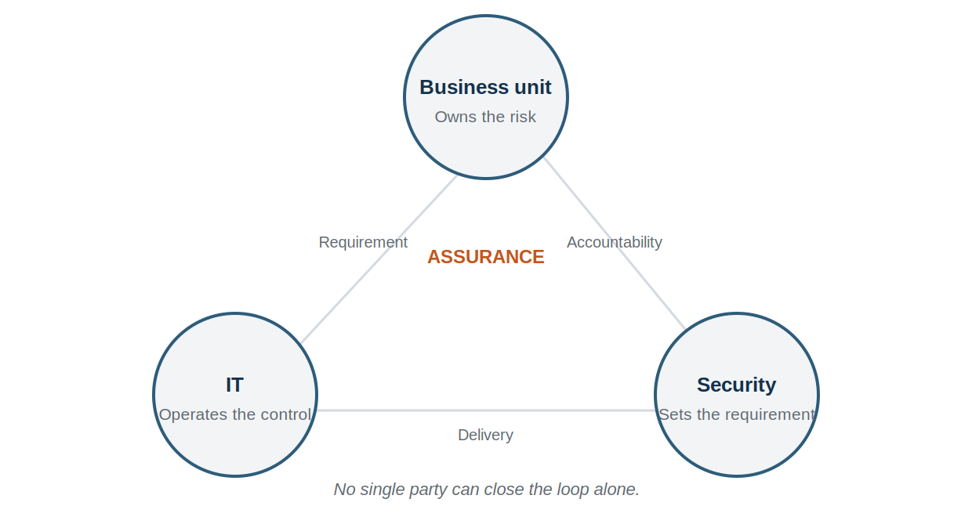
Figure 1. The three parties to a patching decision and what each contributes.

2.1 Business process owner
The business unit that depends on a system owns the risk of operating it. The business process owner agrees the maintenance windows during which systems may be taken down, accepts the residual risk where a fix is deferred, and is the point of contact for decisions that trade availability against security.
Where no business process owner is named for a system, patching decisions default to IT, which means availability wins by default and the exposure is never formally accepted by anyone.

2.2 Information technology
IT, whether internal or a provider, is responsible for identifying applicable patches, testing them where testing is warranted, applying them within the required period, and reporting on what was applied and what was not.
IT is not responsible for deciding whether a system may be taken down, and should not be placed in a position of making that decision alone.

2.3 Security
Security sets the required remediation periods, classifies severity, advises on compensating controls where no patch exists, and verifies that remediation actually occurred. Security does not apply patches, because the party that applies a fix cannot independently verify it.

3. Layered dependency
A vulnerability does not exist in isolation. A securely written application running on an unpatched host is exposed. A patched host in a facility with no access control is exposed. Assessment that stops at the application layer produces a false result.
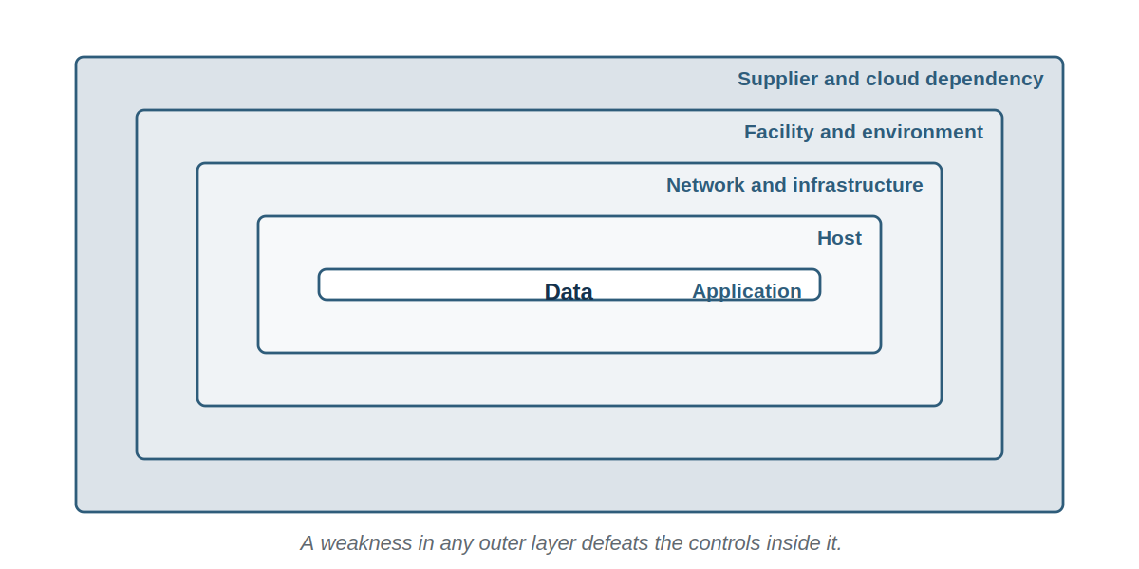
Figure 2. Each layer inherits the weaknesses of every layer outside it.
The practical consequence is that standing assessments should exist for the layers everything else depends on: the network, the hosting environment, the identity platform, and the configuration baselines for common system types. Those assessments are then referenced by system-specific work rather than repeated within it.

4. The window of exposure
The period during which a vulnerability can be used against the organization is the window of exposure. It has three phases, each controlled by a different party. Distinguishing them matters because only one of the three is within the organization's control, and effort spent on the others is wasted.

4.1 The unknown window
From the moment a flaw exists until it is publicly disclosed. This phase is controlled by whoever found the flaw. If that is a researcher, disclosure follows. If it is an attacker, an exploit may be in use long before anyone else knows the flaw exists.
Nothing specific can be done about an unknown flaw. The only defence is layered controls that reduce what any single weakness achieves: segregated networks, least privilege, isolated backups and monitoring that detects the consequences of an exploit rather than the exploit itself.

4.2 The vendor window
From public disclosure until a patch is available. This phase is controlled by the vendor. The organization cannot shorten it, but it can reduce exposure during it by applying the vendor's interim mitigation, removing the exposure, or accepting a temporary loss of function.
This window is the one most often ignored, because the absence of a patch is treated as the absence of an action.

4.3 The owner window
From the availability of a patch until the patch is installed. This phase is controlled entirely by the organization. It is the only phase the program can shorten by decision rather than by hope, and it is the phase against which the organization will be judged after an incident.
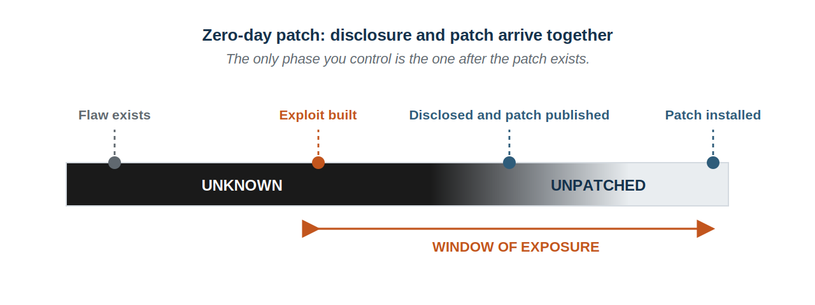
Figure 3. Where disclosure and patch arrive together, only the owner window exists. All exposure is self-inflicted.
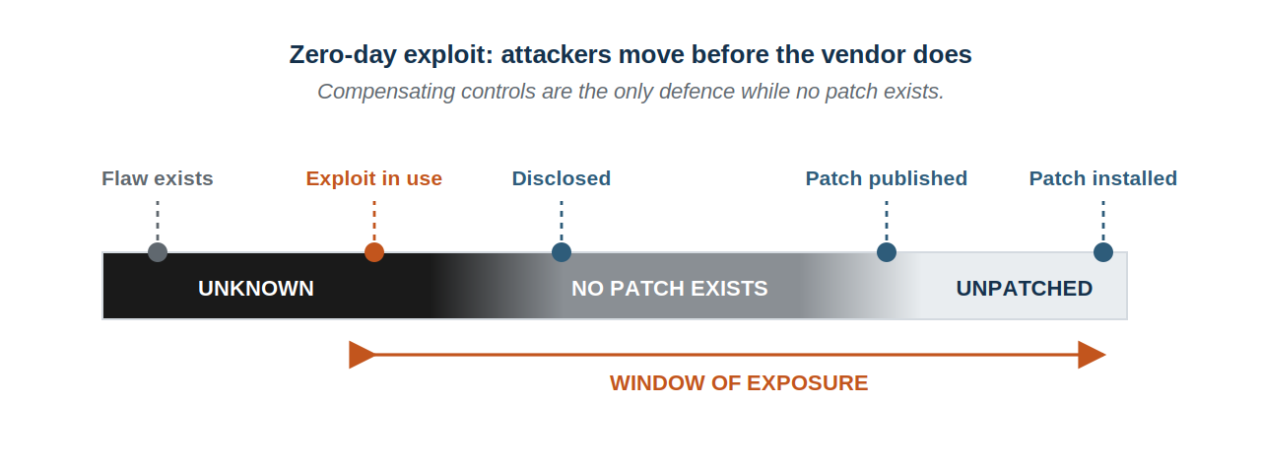
Figure 4. Where an exploit precedes the patch, the vendor window opens and compensating controls are the only available response.
The number that matters
Most vendor patches are published at the same time as the disclosure. In those cases the vendor window does not exist, and the entire window of exposure is the time the organization took to install the patch.
That figure is measurable, it is attributable, and it is the first thing an insurer or a regulator will ask for after an incident.

5. Program requirements

5.1 Asset inventory
The organization shall maintain an inventory of every asset within scope, recording the asset, its owner, the business process it supports, its exposure, and the party responsible for patching it.
The inventory shall be reconciled at least quarterly against network discovery and against procurement and expenditure records, so that assets acquired outside the formal process are identified. An asset absent from the inventory shall be treated as an unmanaged asset and either brought into scope or removed.

5.2 Categorization by zone
Each asset shall be assigned to a zone. The zone determines how quickly a flaw of a given severity shall be remediated, because the same flaw does not carry the same urgency on an internet-facing payment system as it does on an isolated test machine.
Zone 1. Exposed and critical
Reachable from the internet and handling sensitive information or payments.
Public web applications, payment systems, remote access gateways, external mail.
Zone 2. Exposed
Reachable from the internet but not handling sensitive information.
Marketing sites, public file transfer, guest wireless.
Zone 3. Internal and critical
Not reachable from the internet, but supporting a process the organization cannot operate without.
Finance systems, the identity platform, primary file storage, backup infrastructure.
Zone 4. Internal
Not reachable from the internet and supporting processes that can tolerate interruption.
Internal tooling, meeting room equipment, printers.
Zone 5. Isolated or legacy
Segregated from the wider network, or unable to be patched, and retained under a recorded exception.
Legacy line of business systems, unsupported embedded devices.

5.3 Remediation periods
Remediation shall commence within the period stated below, measured from the date the patch became available or the flaw was identified, whichever is earlier. Commencement means the work is scheduled and resourced, not merely acknowledged.
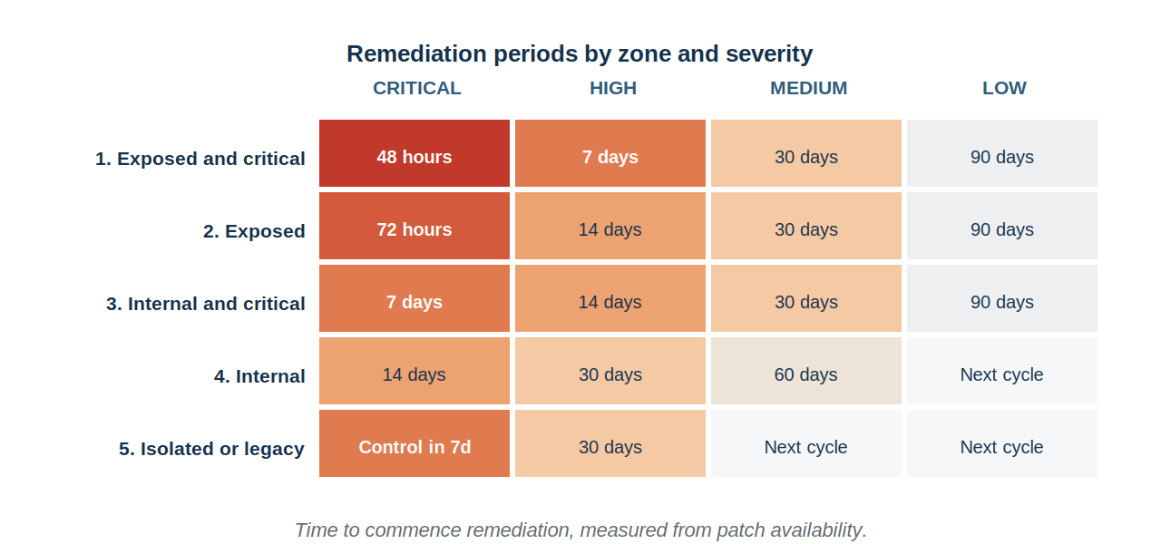
Figure 5. Remediation periods by zone and severity.
Where a vulnerability is known to be actively exploited, it shall be treated as critical regardless of its published severity score, and remediated within 48 hours in any zone.
Why this commits to numbers
A program that requires remediation 'promptly' or 'in a timely manner' cannot be complied with or breached, which means it cannot be measured or enforced.
These periods are a defensible starting point. Adjust them to what the organization can actually achieve, then meet them. A period that is missed every month is worse than a longer period that is met.

5.4 Identification
- Vulnerability scanning shall be performed against external-facing assets at least monthly, and after any change to an externally reachable service.
- Internal scanning shall be performed at least quarterly across all zones.
- Discovery scanning shall be performed at least quarterly to identify assets absent from the inventory.
- Vendor security advisories shall be monitored for every product in the inventory, and a named individual shall be responsible for reviewing them.
- Findings from penetration testing, assessments and incidents shall enter the same remediation process as scan findings, and shall not be tracked separately.

5.5 Remediation
- Patches shall be tested before deployment where the affected system supports a critical process, and deployed directly where the risk of delay exceeds the risk of disruption.
- A rollback position shall be established before a patch is applied to a system supporting a critical process.
- Remediation shall be verified by rescanning or by direct inspection, and shall not be recorded as complete on the basis of a deployment report alone.
- Verification shall be performed by a party other than the one that applied the fix, wherever the organization's size permits.
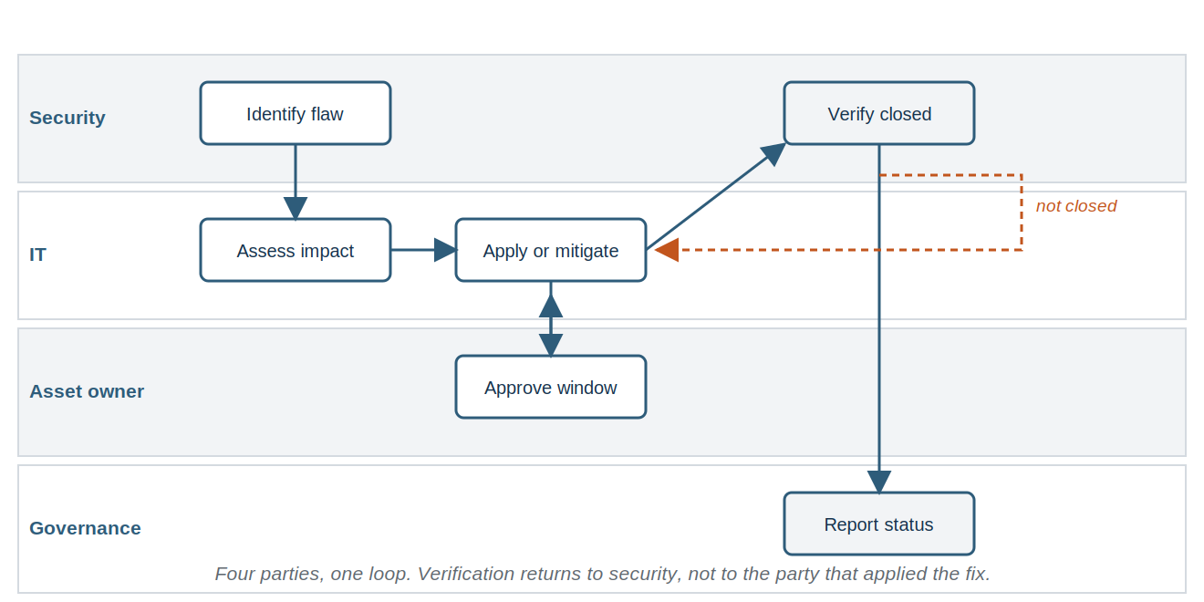
Figure 6. The remediation loop. Verification returns to the party that set the requirement.

6. Enforcement
A requirement without a consequence is a recommendation. The following shall apply where remediation does not occur within the period stated in section 5.3.
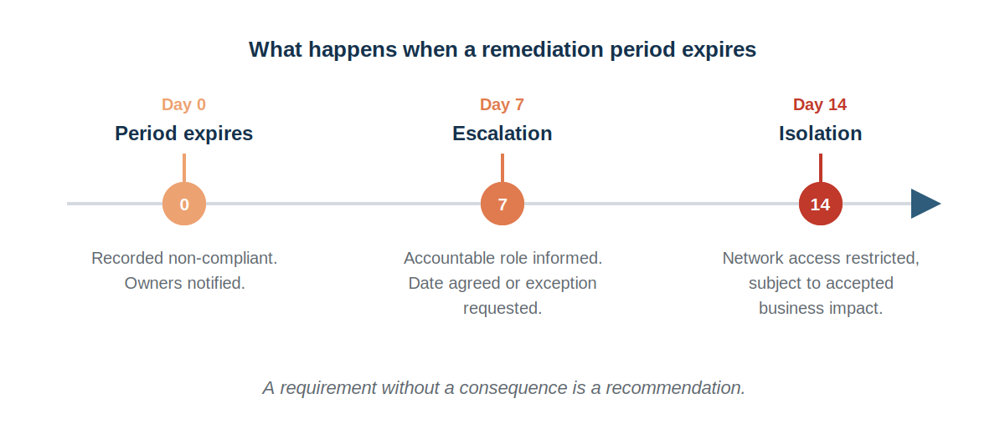
Figure 7. The escalation sequence when a remediation period expires.
Day 0 | The asset is recorded as non-compliant. The asset owner and the business process owner are notified, with the finding, the severity and the date the period expired.
Day 7 | Escalation to the accountable role. The business process owner is required either to agree a remediation date or to request a formal exception under section 7.
Day 14 | Where no exception has been approved, network access for the asset is restricted or the asset is removed from the network. The business impact is assessed and accepted by the accountable role before this occurs.
Where isolation is not feasible | Compensating controls are implemented under section 9 and the residual exposure is recorded as an accepted risk with a named approver and a review date.
Non-compliance shall be reported to the governance forum with the asset, the zone, the severity, the age of the finding and the reason it remains open.

7. Exceptions
An exception shall be requested in writing where a system cannot be remediated within the required period. Each exception shall record the asset, the vulnerability, the reason remediation is not possible, the compensating controls applied, the residual risk, the approver and an expiry date.
Exceptions shall not be granted indefinitely. An exception renewed more than twice shall be escalated as a decision about whether to replace or decommission the system, because a permanent exception is a permanent exposure that nobody has deliberately accepted.

8. Vendor-maintained and supplier systems
Where a supplier maintains a system on which the organization depends, the organization cannot patch it and shall instead establish the following contractually.
- The remediation periods the supplier commits to, by severity.
- The supplier's obligation to notify the organization of vulnerabilities affecting the service.
- The organization's right to receive evidence of remediation, or the results of the supplier's own scanning.
- The notice period for maintenance that will interrupt the service.
- What happens where the supplier declines to remediate a vulnerability the organization considers material.
Where these cannot be established, the residual exposure shall be recorded as a risk owned by the business process owner rather than treated as the supplier's problem.

9. Compensating controls
Where a vulnerability cannot be remediated, the exposure shall be reduced by other means. Compensating controls do not remove the vulnerability and shall not be recorded as remediation.
Preventive
Stop the exploit succeeding. Network segregation, firewall rules, removing the exposed service, or restricting the accounts and addresses that can reach the asset.
Detective
Notice the exploit occurring. Additional logging on the asset, alerting on anomalous access, and file integrity monitoring where the asset cannot be otherwise protected.
Corrective
Limit the damage once it occurs. Isolated backups, tested restoration, and the ability to disable the asset quickly without waiting for a decision.
Deterrent
Reduce the attractiveness of the target. Suppressing version banners, removing the asset from search indexes, and reducing the information the service discloses before authentication.

10. Measurement and reporting
The following shall be reported to the governance forum at least quarterly. Measures shall be consistent between reports so that a trend is visible.
Open findings by severity and zone. Shows where exposure is concentrated rather than only how much of it there is.
Proportion remediated within the required period. The single measure of whether the program operates. Everything else is context for this figure.
Age of the oldest open critical finding. Detects findings that are being carried from report to report rather than closed.
Number of active exceptions and their age. Detects exposure that has been normalized. An exception register that only grows is a program in retreat.
Assets discovered that were absent from the inventory. Measures whether scope is under control. A rising figure means discovery is working; a figure of zero usually means it is not running.
Mean time from patch availability to installation. The owner window expressed as a number. This is the figure an insurer or a regulator will ask for after an incident.
Raw scan counts shall not be reported without context. A rising count may indicate improved discovery rather than deteriorating security, and a falling count may indicate scanning that has stopped working.

11. Review
This program shall be reviewed at least annually, and additionally after any incident arising from an unremediated vulnerability, any material change to the estate, and any change to the organization's obligations. Each review shall be recorded whether or not the content is amended.

12. Vulnerability identification in detail

12.1 Sources of vulnerability information
No single source identifies every vulnerability. A program relying only on scanning will miss configuration weaknesses, absent capability and anything affecting a system the scanner cannot reach.
Authenticated scanning
Scanning performed with credentials, which reads installed software versions and configuration directly. Produces materially more accurate results than unauthenticated scanning and far fewer false positives. The credentials used shall be dedicated to scanning, shall hold only the privileges scanning requires, and shall be monitored for use outside scan windows.
Unauthenticated scanning
Scanning from the perspective of an attacker without credentials. Less accurate, but it establishes what is visible from outside and therefore what an attacker sees first. Both types are required; neither substitutes for the other.
Vendor advisories
Notifications issued by software and hardware vendors. A named individual shall be responsible for reviewing advisories for every product in the inventory, because a scanner that does not yet have a signature for a flaw will not report it.
Exploitation catalogues
Published lists of vulnerabilities observed in active use. A flaw appearing on such a list is treated as critical under section 5.3 regardless of its published severity score.
Configuration review
Comparison of a system's configuration against an established baseline. Identifies weaknesses that scanning tools rate as informational or do not report at all, including permissive access, disabled logging and unnecessary services.
Penetration testing
Manual assessment that establishes whether identified weaknesses can actually be chained into a compromise. Addressed in section 14.
Incident findings
Weaknesses identified during an incident. These shall enter the same remediation process as scan findings and shall not be tracked separately, because findings tracked outside the main process are findings that close last.
Reports from personnel and third parties
Including responsible disclosure from researchers and customers. A route for receiving such reports shall be published and monitored.

12.2 Scanning operations

Preparation
- The scope of each scan shall be defined and agreed with the asset owners before the first scan, and reviewed whenever the estate changes materially.
- Asset owners shall be notified of the scan window in advance, so that scan traffic is not investigated as an incident.
- Systems known to respond badly to scanning shall be identified in advance and scanned with reduced intensity or during a maintenance window, rather than excluded.
- A named contact shall be available during the scan window to stop the scan if it causes disruption.
- The scanning platform's own credentials and configuration shall be protected to the standard of any other privileged system, because a compromised scanner is a map of every weakness the organization has.

Frequency
External scanning. At least monthly, and after any change to an externally reachable service. External exposure changes without anyone intending it, through configuration drift and through services published to meet a deadline.
Internal scanning. At least quarterly across all zones, and monthly for zones 1 and 3 where the organization's scanning capacity permits.
Discovery scanning. At least quarterly, to identify assets absent from the inventory. This scan is frequently the most valuable of the three, because it finds what nobody knew was running.
Post-change scanning. Following any significant change to a system in zone 1 or 3, to confirm the change did not introduce exposure.
Validation scanning. Following remediation, to confirm the finding is actually closed. Required by section 5.5 and not substitutable by a deployment report.

Handling scan results
- Results shall be reviewed before entering the remediation process. Raw scanner output contains false positives, duplicates and findings that do not apply to the configuration in use.
- A finding assessed as a false positive shall be recorded as such with the reasoning, and the assessment shall be revisited at the next scan rather than suppressed permanently.
- Findings shall be deduplicated across scans so that the same weakness on the same asset is tracked as one item with an age, rather than as a new finding each month.
- The age of a finding shall run from its first appearance, not from the most recent scan that reported it.
Why suppression is dangerous
Permanently suppressing a finding removes it from every future report, including reports produced for an assessor or an insurer. The suppression is invisible and the exposure remains.
Where a finding genuinely does not apply, record the reasoning and set it to revisit. Where it applies but cannot be fixed, it is an exception under section 7, not a suppression.

13. Patch management in detail

13.1 The patch lifecycle
Assess. Determine whether the patch applies to the organization's estate, which systems it affects, and what it changes. A patch for a component that is installed but not in use still applies, because the vulnerable code is present.
Identify. Establish which specific assets require the patch, from the inventory rather than from assumption. The count of affected assets is frequently higher than expected.
Evaluate and plan. Determine whether testing is warranted, what the rollback position is, which maintenance window applies, and who must be informed.
Deploy. Apply the patch, in a sequence that limits the impact of failure. Pilot group first where the estate permits.
Verify. Confirm the patch installed and the vulnerability is closed, by rescanning or direct inspection.
Record. Record what was applied, to what, when, by whom, and the verification result. This record is the evidence required by Appendix C.

13.2 Testing
Testing reduces the risk of a patch causing disruption. It also delays remediation, which is itself a risk. The balance shall be set by zone and severity rather than applied uniformly.
Where testing is required
Systems supporting a critical process, systems with custom or heavily integrated software, and any system where a failed patch would be difficult to reverse. Testing shall occur in an environment that resembles production sufficiently for the result to mean something.
Where testing is not required
Standard end user devices, systems with no custom software, and any case where the vulnerability is being actively exploited and the risk of delay exceeds the risk of disruption.
Where testing is impossible
Some systems have no test equivalent. In those cases a pilot deployment to a small group shall substitute for testing, with a defined observation period before wider deployment.
The decision is recorded
Whether testing occurred, and the reasoning where it did not, shall be recorded. An untested patch that caused an outage is a defensible decision if the reasoning was recorded in advance, and an indefensible one if it was not.

13.3 Deployment
- A rollback position shall be established before a patch is applied to any system supporting a critical process. Where rollback is not possible, a current backup shall be confirmed before deployment.
- Deployment shall proceed in stages where the estate permits: pilot group, then a wider group, then the remainder, with an observation period between stages.
- Maintenance windows shall be agreed with business process owners in advance and published, so that the organization is not negotiating a window each time a patch is released.
- Where a patch requires a restart, the restart shall be part of the deployment rather than deferred. A patch installed but not activated has not remediated anything, and this is a common reason verification fails.
- Failed deployments shall be recorded and investigated, not simply retried. A pattern of failure on the same assets usually indicates an underlying problem with those assets.

13.4 Systems that cannot be patched
Some systems cannot be patched: the vendor no longer issues updates, the system is certified in a configuration that patching would invalidate, or the operational risk of change is judged to exceed the security risk.
- Record the system, the reason, and the vulnerabilities that consequently remain open.
- Assign the system to zone 5 and apply the compensating controls required by section 9.
- Record the residual exposure as an accepted risk with a named approver and a review date.
- Establish a replacement or decommissioning date. A system that cannot be patched is a system with a finite remaining life, and treating it otherwise is how a temporary exception becomes a permanent exposure.
- Review at each cycle whether the compensating controls remain effective and whether the replacement date remains realistic.

14. Penetration testing

14.1 Purpose
Scanning identifies known weaknesses individually. Penetration testing establishes whether they can be combined into a compromise, and whether the organization would notice. The two are complementary and neither substitutes for the other.
A penetration test performed on an estate that has never been scanned will spend its time finding what a scanner would have found for a fraction of the cost. Scanning first is not a preliminary; it is what makes the test worth buying.

14.2 Scoping
- The objective shall be stated in business terms before the scope is set. Testing to satisfy a customer requirement and testing to establish whether an attacker could reach customer data produce different engagements.
- The scope shall state what is included, what is excluded, and what the tester may and may not do.
- Rules of engagement shall cover testing hours, any action requiring prior approval, and how the tester reports something that requires immediate attention.
- The organization shall decide in advance whether the technical team is informed, and record the decision. Testing without informing them also tests detection.
- A named contact shall be reachable throughout the engagement.

14.3 Types
Black box
The tester begins with no information beyond what is publicly available. Establishes what an external attacker would achieve. Spends a proportion of the engagement on discovery that the organization could have provided.
Grey box
The tester begins with limited information, typically standard user credentials. Establishes what a compromised user account or a malicious insider could achieve, which is the scenario most organizations actually face.
White box
The tester receives full information including architecture and configuration. Produces the most thorough result for the time spent, and is appropriate where the objective is to find weaknesses rather than to simulate an attacker.

14.4 Handling findings
- Findings shall enter the same remediation process as scan findings, with the same periods applying by zone and severity.
- Findings the tester rates as critical shall be reported during the engagement rather than in the report, and the rules of engagement shall require this.
- The report shall be treated as confidential and shall be retained securely. It is a map of the organization's weaknesses.
- Retesting shall be arranged for findings rated high or above, and shall be included in the original engagement rather than negotiated afterwards.
- The organization shall record what the test did not cover, because a report is frequently read later as though it covered everything.

15. Exception process in detail

15.1 When an exception is appropriate
An exception is appropriate where remediation is genuinely not possible within the required period, not where it is inconvenient. The distinction shall be tested by the approver rather than asserted by the requester.
Legitimate. No patch exists. The vendor no longer supports the product. Patching would invalidate a certification. The system cannot be taken down within the period and the business impact of doing so exceeds the security risk.
Not legitimate. Nobody has time. The maintenance window is inconvenient. The system owner has not responded. The patch has not been tested and nobody has scheduled testing.

15.2 What an exception request records
- The asset, the vulnerability and its severity.
- The remediation period that will be exceeded, and by how long.
- Why remediation is not possible within that period.
- The compensating controls that will be applied, and when.
- The residual exposure after those controls, expressed as a business consequence.
- The proposed expiry date and what will have changed by then.
- The requester, the approver, and the date of approval.

15.3 Review and expiry
On approval | Compensating controls implemented within the period stated in the request. The exception is entered in the register.
At expiry | The exception lapses. Either remediation has occurred, or a fresh request is made with current reasoning.
Second renewal | Escalated to the accountable role as a decision about whether the system should be replaced or decommissioned.
Quarterly | All active exceptions reviewed. Those whose compensating controls have not been implemented are escalated.
Annually | The register is reviewed as a whole. A register that only grows indicates a program accumulating exposure rather than managing it.

16. Reporting in detail

16.1 Operational reporting
Produced monthly for those operating the program. Covers findings raised and closed, findings approaching their period, failed deployments, and assets not scanned in the current cycle.

16.2 Management reporting
Produced quarterly for the governance forum. Covers the measures in section 10, the exception register, and any decision required. Written so that a reader without technical background can act on it.
- Lead with what changed since the previous report, not with what the program does.
- Express exposure as business consequence rather than as finding counts.
- Name the decisions required, with options and a recommendation.
- Report commitments from the previous period and whether they were met, including those that were not.

16.3 Reporting to customers and assessors
Where a customer or assessor requests information about the program, the organization shall provide the process, the periods and the evidence that the process operates. It shall not provide the finding register itself, which is a list of current weaknesses.

Appendix D. Exception request form
Field | Entry
Asset
Zone
Vulnerability and identifier
Severity
Required remediation period
Period requested
Why remediation is not possible
Compensating controls to be applied
Date controls will be in place
Residual exposure in business terms
Proposed expiry date
What will have changed by expiry
Requested by, date
Approved by, date
Review date

Appendix E. Scan schedule
Completed and maintained by the party operating the scanning. Reviewed at each management report.
Scan type | Scope | Frequency | Window | Operated by | Last run
External |  | Monthly
Internal, zones 1 and 3 |  | Monthly
Internal, all zones |  | Quarterly
Discovery |  | Quarterly
Post-change |  | On change
Validation |  | On remediation

Appendix F. Remediation record
The evidence required by section 5.5 and Appendix C. Retained for the period required by the organization's retention schedule.
Finding | Asset | Severity | Raised | Due | Action taken | Verified | By

Appendix A. Roles and responsibilities
This appendix forms part of the program.
Accountable role
Owns this program. Approves exceptions and remediation periods. Decides on isolation where a business impact is contested. Reports to the governance forum.
Business process owner
Owns the risk of operating the system. Agrees maintenance windows. Accepts residual risk where remediation is deferred. Confirms business impact before isolation.
Asset owner
Maintains inventory accuracy for their assets. Confirms the zone assignment. Ensures assets are reachable by scanning.
IT provider or internal team
Identifies applicable patches. Tests where warranted. Applies remediation within the required period. Reports what was applied and what was not.
Security
Sets severity and remediation periods. Advises on compensating controls. Verifies remediation independently of the party that applied it.
Internal audit
Tests whether the program operates as documented, independently of those who operate it.
All personnel
Report systems and services in use that may not be recorded in the inventory.

Appendix B. The proof chain
This appendix is guidance and does not form part of the program.
Remediation recorded is not remediation demonstrated. The distinction below applies to every control in this program and is the reason section 5.5 requires verification independent of deployment reporting.
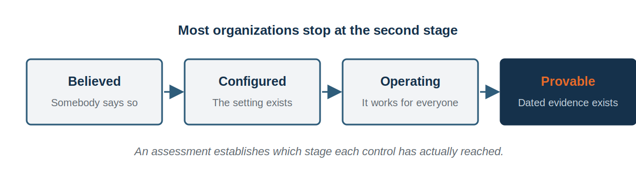
Figure 8. The four stages of a control, and where most programs stop.
A deployment report establishes that a patch was sent. It does not establish that the patch installed, that it installed everywhere, or that the system is no longer vulnerable. Only a rescan or direct inspection establishes the last of those, and only a dated record of that rescan makes it provable to somebody else.

Appendix C. Evidence of operation
This appendix is guidance and does not form part of the program.
Requirement | Evidence that demonstrates it | Population it must cover | Held | Date
Inventory (5.1) | Inventory reconciled against discovery and expenditure records | All assets in scope
Zone assignment (5.2) | Inventory showing a zone against every asset | All assets in scope
External scanning (5.4) | Scan reports at the required frequency | All externally reachable assets
Internal scanning (5.4) | Scan reports at the required frequency | All zones
Advisory monitoring (5.4) | Record of advisories reviewed and the decision taken | All products in the inventory
Remediation within period (5.3) | Report of findings closed against their due date | All findings in the period
Verification (5.5) | Rescan or inspection record, dated after remediation | All closed findings
Enforcement (6) | Record of escalations and isolations performed | All findings exceeding their period
Exceptions (7) | Exception register with approver, compensating control and expiry | All active exceptions
Supplier obligations (8) | Contract clauses stating remediation periods | All suppliers maintaining in-scope systems
Reporting (10) | Reports to the governance forum | All periods since the last review

Glossary

Acronyms
Acronym | Expansion
BPO | Business process owner
CVE | Common Vulnerabilities and Exposures, the identifier scheme for publicly known flaws
CVSS | Common Vulnerability Scoring System, the severity scoring scheme
EOL | End of life, the point after which a vendor no longer issues patches
KEV | Known Exploited Vulnerabilities, a catalogue of flaws observed in active use
RTO | Recovery time objective
SLA | Service level agreement

Definitions
Term | Definition
Vulnerability | A weakness that could be used to gain unauthorized access, cause loss, or prevent the organization operating.
Patch | Code issued by a vendor to correct a flaw. Not all vulnerabilities have a patch.
Remediation | Removal of the vulnerability, ordinarily by applying a patch or correcting a configuration.
Mitigation | Reduction of the likelihood or impact of exploitation without removing the vulnerability.
Compensating control | A measure applied where remediation is not possible, reducing exposure without removing the vulnerability.
Window of exposure | The period during which a vulnerability can be used against the organization, comprising the unknown, vendor and owner windows.
Owner window | The period between a patch becoming available and its installation. The only phase the organization controls entirely.
Zone | A category assigned to an asset determining how quickly a flaw of a given severity is to be remediated.
Actively exploited | A vulnerability observed in use against real targets, which raises its urgency above its published score.

Record of changes
Each review is recorded below, whether or not the content is amended. A document reviewed and found still correct should say so.
Version | Date | Author | Summary of change | Approved by
1.0 |  |  | First issue

Published free by RootGuard Security. This program states requirements. It does not establish whether those requirements are met, which requires evidence. rootguardsecurity.com

